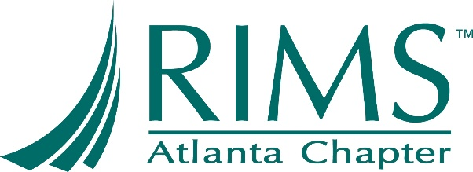

27th Annual Walter H. Buce, Jr. Memorial Award
Sponsored by Atlanta Chapter of RIMS

Nomination Form
The award will be presented at the Atlanta RIMS Education Conference on February 2nd, 2023.

Nominee’s Name _____________________Designations________________
Nominee’s Company_________________________________________________
Company Address _____________________________________
Phone ___________ Fax ____________________
Email address __________________________________________

Please describe below why the above-named nominee should be considered. When making a nomination, take into consideration the nominee’s standing in the community, his or her individual accomplishments and contributions to the insurance industry. (If you need additional space, please feel free to attach a separate document.)

_________________________________________________________________________________________________________________________________________________________________________________________________________________________________________________________________________________________________________________________________________________________________________________________________________________________________________________________________________________________________________________________________________________________________________________________________________________________________________________________________________________________________________________________________________________________________________________________________________________________________________________________________________________________________________________________________________________________________________________________________________________

Submitted by (name & email address) _______________________________________________
Company __________________ Daytime Phone _____________ ______
Date _________

Please return nomination forms by Friday, December 9, 2022 to:

Brian Murdock
Atlanta RIMS Awards Committee
Email: bmurdock@synapsellc.com

